|  |  |  |
| --- | --- | --- |
| C:\Users\S4C\Dropbox\Methods\eu_flag_co_funded_pos_[rgb]_right.jpg  Project Number: 561708-EPP-1-2015-1-DE-EPPKA2-CBHE-JP | | |
| D:\VTC\logo-BAU.jpg |  |  |

**Training materials:**

Vocational training center for undergraduate university students and teachers in Jordan (VTC) project

P 8: Al-Balqa Applied University (BAU)

**Basic Fundamentals in Project Management: Internationalization, Networking and Project Cooperation Opportunities in Higher Education**

**Time of conduct:** Oct. 24, 2017/ 2 hrs

**Trainer:** Dr. Gálová Janka**/** Slovak University of Agriculture in Nitra

**Aim:** to present an insight to project management from the theoretical and practical point of view, with presenting some best practice ideas from the field from the experience of the SUA in Nitra and Slovak universities in general

**Target group:** the graduate students from different specialties

**Training methods used:** lectures, group discussions, brainstorming, and power point presentations

**Participants:** 34 students and 10 staff members

**Training objectives:** Internationalization in case of universities means creating links and strengthening cooperation with partners all around the world in order to ensure study or research opportunities with different aims and for various target groups, students as well as teaching and other staff included. The Faculty of Economics and Management of the Slovak University of Agriculture in Nitra, Slovakia is an active applicant in most of the published project calls. Several years of experience is used in managing and administering projects within the frameworks such as CEEPUS (Central European Exchange Program for University Studies), Erasmus+ (framework program for education, training, youth and sport), including Erasmus Mundus and TEMPUS programs. These possibilities offer study and research mobilities that benefit both the participants and the home and host universities, by providing feedback from their practice to be applied in future projects

**Photos:**

**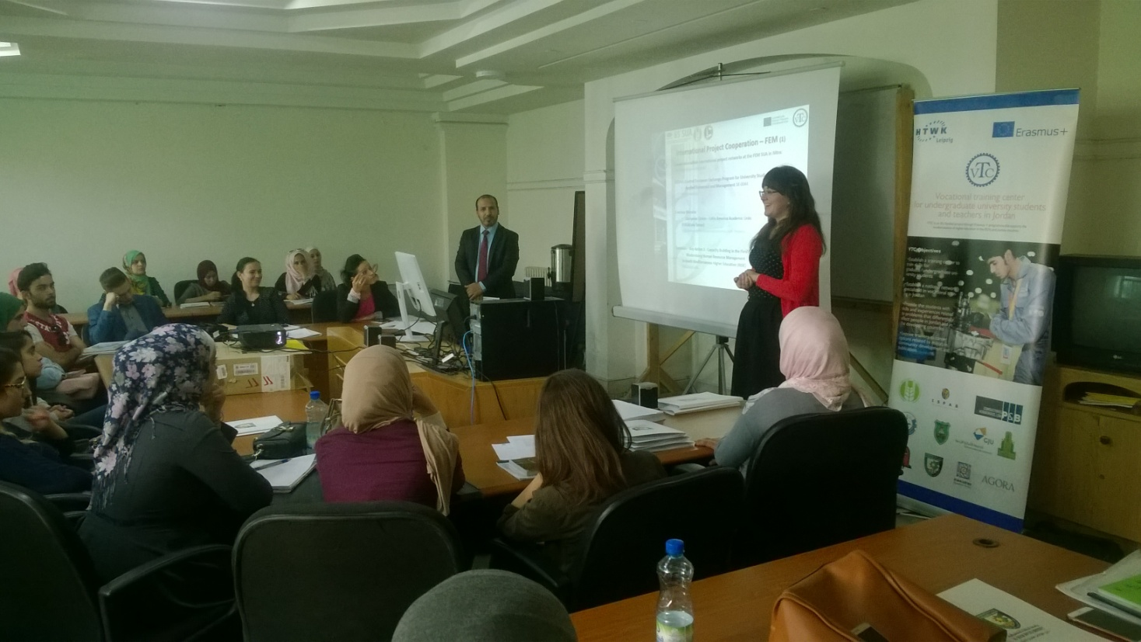**

**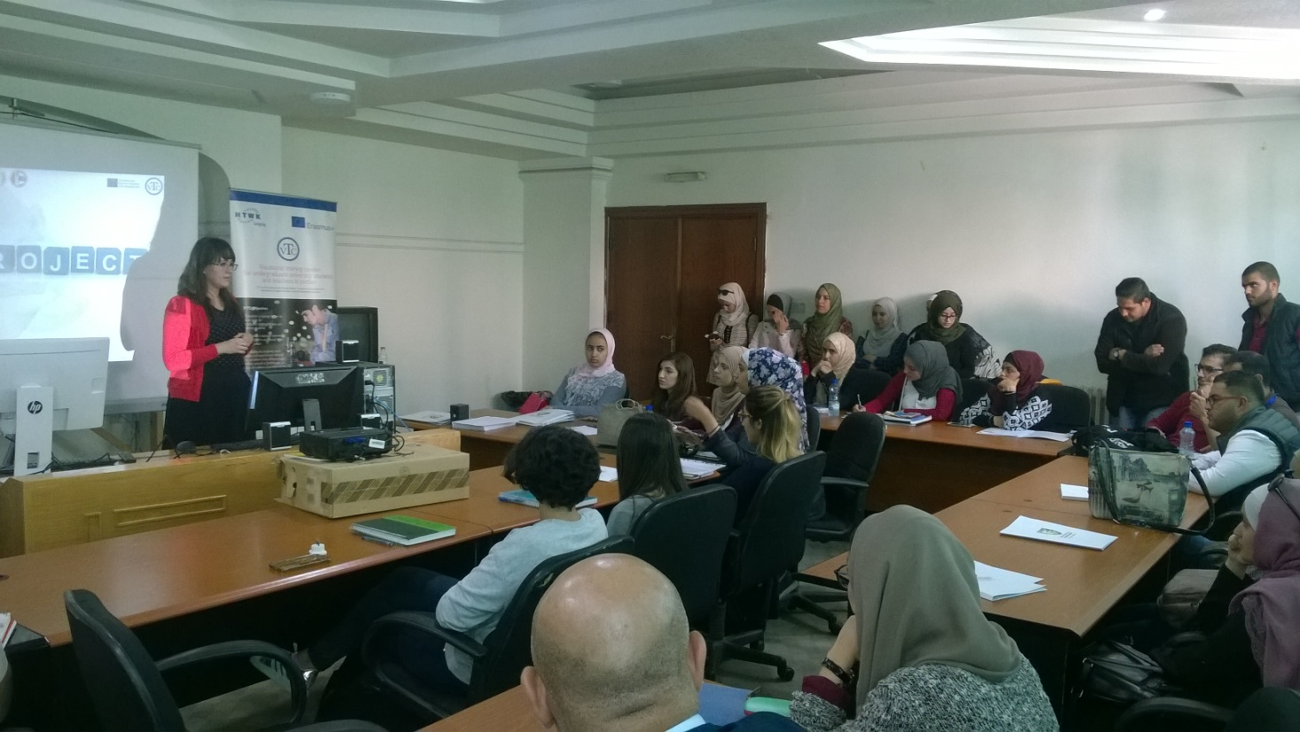**

**Expected Outcomes:**

Graduate students are able to manage their project successfully

**Quality control:** training was controlled and then analyzed at the end. According to the attendance lists, more than 80% of the participants were answered the evaluations. The surveys contained questions (5-point Likert scale), in which respondents had to give a grade between 1 and 5, with 5 being the highest (fully agree) and 1 the lowest (fully disagree). All the evaluation items in the training were above good.